# How to run the code?

Option : 1 🡪

* Go in Goolgle’ Kaggal platform and create a profile there.
* After successful creation of profile, click on ‘+ Create’ button
* Then click on New Notebook
* Paste code of AttendanceModel.ipynb in your notebook created on Kaggal
* Upload the provided “2018-2019_Daily_Attendance_20240429.csv”
* Run code after making slight changes.

Note: if you face any error during execution , please paste error details in Chatgpt and it will advice you about steps to rectify the error

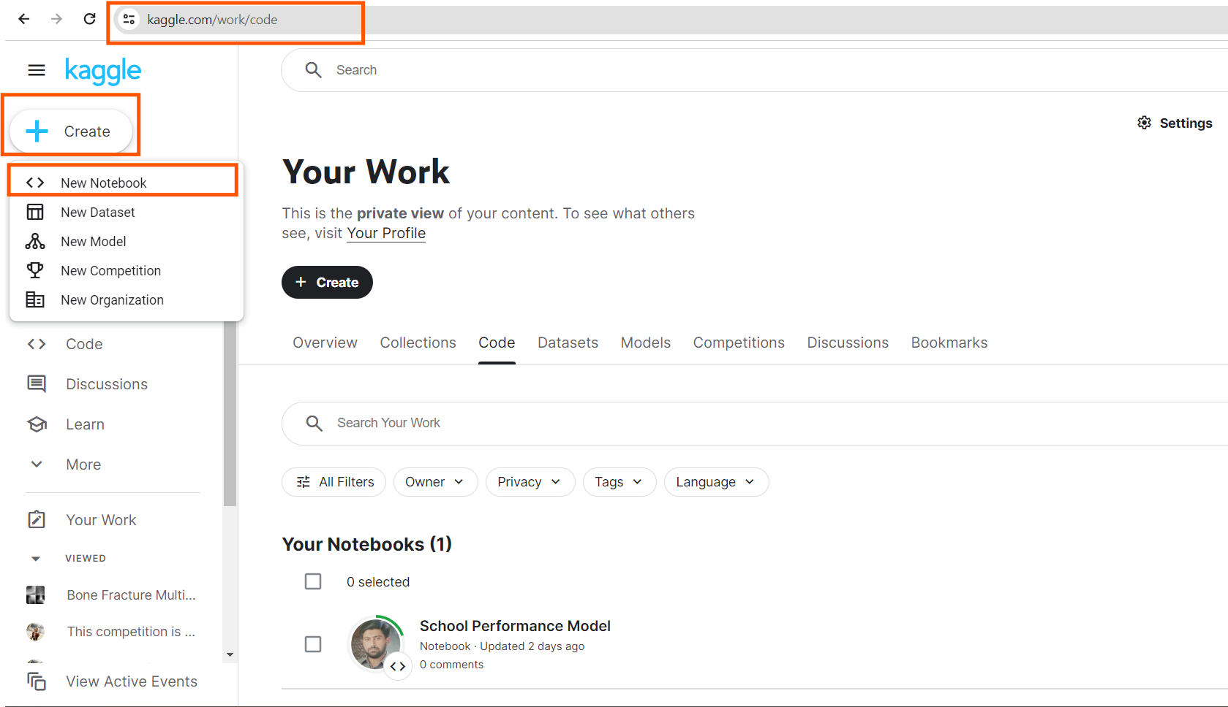

Option # 2 🡪

* Download Anaconda navigator on your PC
* Click on Anaconda icon

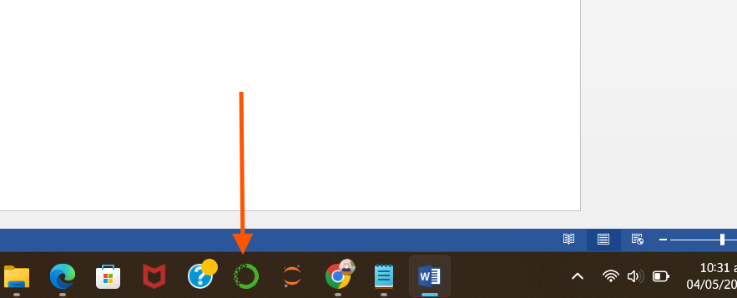

* Launch Jupyter Notebook, and paste code in it.
* Make slight changes and run it

